2015-ZA-01-EN.odt Compass Rose
0 ---- | I: ---- | II: hard | III: medium | IV: ----

Answer Type: Click to choose! Mandatory for: none

Body

On the map below, the numbers represent islands. A compass rose is provided to indicate North, South, East and West.
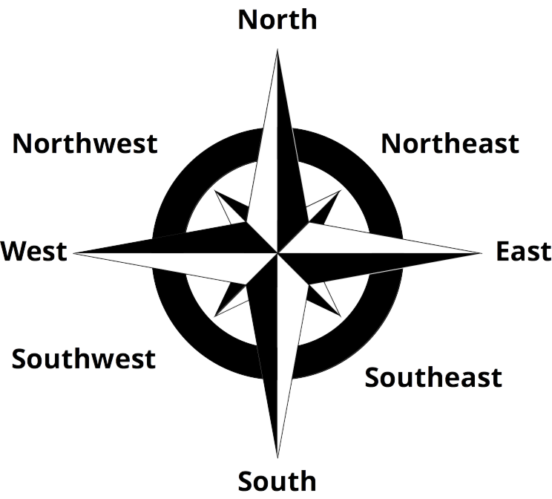
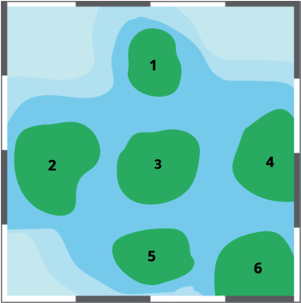
The names of the islands are A, B, C, D, E and F but we do not know the positions of the islands. We are given the following information:
C is South of A and Southeast of D.
B is Southwest of F and Northwest of E.
D is South of F.

Question

Which island is at position 6?

Answer

Correct answer is C

Explanation

“C is South of A and Southeast of D” gives the following configuration:
D | A
 | C

“B is Southwest of F and Northwest of E” gives the following configuration:

F
B
E

“D is South of F” allows us to combine the two configurations above to make the following:

 | F
B | D | A
 | B | C

Where we can see that island C is in position 6.

It's informatics

Sometimes a problem takes logical step by step reasoning and repeated testing to find a solution. This particular problem requires a step by step placing of the islands with each step being tested before the next is implemented.

Keywords

Abstraction, reasoning, testing, solution

Websites

Wording

Compass rose, island

Comments

Author, e-mail, Date (YYYY-MM-DD), Comment.

Group 6: it can be made interactive by letting to write letters in city places (or drag them into places).

It could be made harder for seniors to identify island in position 5 with information: ''C is south of A and south-east of D. B is south-west of F, D is south of F“ as was suggested by Rostyslav Shpakovych.

Sher Minn Chong (sherminn.chong@gmail.com) 2015-05-28, Added a more detail explanation of how the islands' positions can be combined with the given descriptions.
Change hyphenated directions to one word directions.
Change map to islands instead.

Graphics

Map.svg created by Group 6, Sher Minn Chong
compass-rose.svg taken from openclipart: https://openclipart.org/detail/142441/compass-rose-bw

Files

All additional files for this task (graphics, scripts, etc.)
2015-ZA-01-EN.odt (this file)
map.svg
compass-rose.svg

Authorship

List all authors who have contributed to this Document, with e-mail and country.

License

Copyright © 2014 Bebras – International Contest on Informatics and Computer Fluency. This work is licensed under a Creative Commons Attribution-NonCommercial-ShareAlike 3.0 Unported License (CC BY-NC-SA 3.0). Visit: http://creativecommons.org/licenses/by-sa-sa/3.0/

